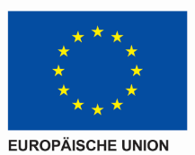
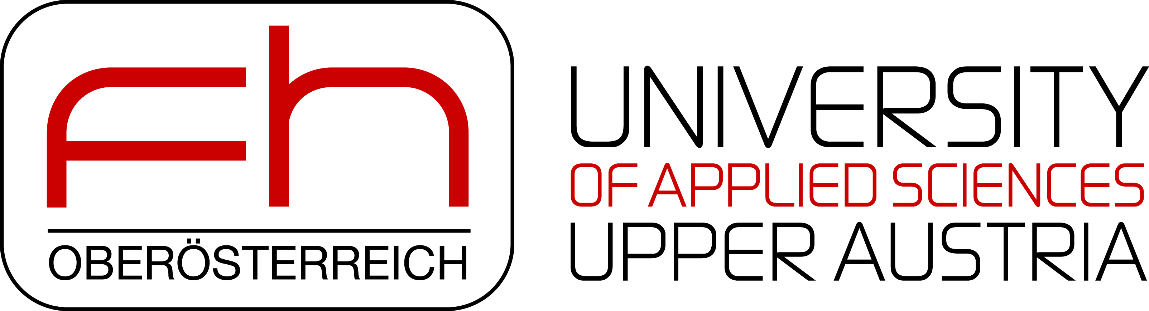
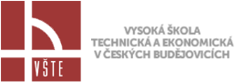
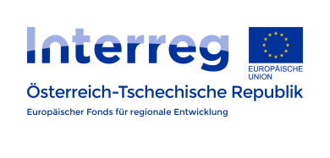

Protocol – Project Team Meeting

25.01.2018
Protocol # | 1/2018
Description | Project Team Meeting
Place | VSTE v Ceských Budějovicích, Ceské Budějovice
Date | 25.01.2018
Time | 09:00 – 13:00
Participants | FH-OÖ: Martina Gaisch Victoria Rammer  VSTE: Jan Gregor, Libuse Turinska
Subjects of the meeting | - Monitoring report:  - both partners agreed there were no bigger problems with monitoring report and agreed on cooperating (providing relevant materials) on the next report  - Budget changes:  - smaller budget changes are planned on the side of the Czech partner (shifting money from the individual items within one package)  - some changes are planned on the side of the Austrian partners (splitting the budget: to external expertise, travel costs within and beyond the program area, workshop budget)  - Project changes:  - Splitting budget items – Austrian side, Czech side – probably necessary to shift money e.g. from monographies, journal publications  - Monographs (formal changes) will be discussed at the next project meeting. Probably changing the designation “Monograph” for Project report / research report  - Discussion of the changes will take place on 06.04.2018 – Next project meeting in Hagenberg. After this the request for change has to be submitted as soon as possible to the authority otherwise financial problems occur concerning the workshop in Hagenberg and conferences (CCBC, EAIR) within this period.  - Preparation of all project changes (formal, budget, etc.) till 06.04.  - Web pages:  - Both partners now have the necessary access  - layout of new improved version of web pages was introduced by Austrian partners  - Final improvements will be done after some necessary changes in financing / checking the way of financing / by the end of June  - Before the partners can start working on the improvements of the website, 3 offers must be obtained. One offer from the FHOÖ and two others. IMPORTANT: Offers cannot be collected until the budget changes have been approved. For this the changes should be made as soon as possible (discussion next project meeting).  - It was suggested to measure the website traffic  - Modules:  - So far, 25 modules (Czech versions) have been elaborated, 14 of them have already been translated into English. Currently, both partners are working on translating the Czech versions into English (Czech partner) and German (Austrian partner)  - It was agreed to replace 9 modules (Featured philosophical issues, Environmentalism, History of architecture, Creation of educational programs, Socio-cultural and management skills development, Economics and business management - Introduction to the study, Small and medium enterprise, Introduction to branch didactics). with more relevant ones. Both Czech and Austrian partner will send suggestions for new modules (more relevant to the disciplines)  - German modules do not have to be proofread by Czech partners. Translation (German to English) will be done by the Austrian partners  - List of English modules which have to be proof-read will be send by the Austrian partners  - Terminology lists:  - extension and improvements of the existing terminology lists was agreed  - The first examples will be sent to the Austrian partners by the 15 February.  - The existing terminology lists containing terminology used in context should be finished by Mid-March  - E-learning:  - a new format of e-learning materials was introduced and discussed, adding gamification elements, audio  - necessary translations into Czech  - words from terminology lists – involve into self-evaluation tests: 1 small test at the end of the presentation, one big test for each discipline  - Workshop in June:  - Possible dates discussed – agreed on June 21  - Austrian partners – ensure lecturers  - Participation – 10 people from the Czech side – people involved in the projects – experts, creators of modules, linguists, students  - Conferences and publishing activities:  - End of August – prob. participation of both partners in Budapest (EAIR, 26 – 29th August); discussed possible joint article: compare utility of the Interreg projects: AT vs. CZ point of view  - Steyr (16th – 18th May): discussed the target group (logistics students, Bachelor´s study program, 50 students, full-time study)  Decided to use a questionnaire: preferences (e-learning) – C vs. A students., questions will be sent to Czech partners, afterwards sent to students. 3 block of questions: culture, learning + cognitive styles + learning preferences, e-learning materials  - Next cooperation: both partners consider further cooperation after the completion of the existing project

