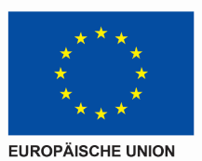
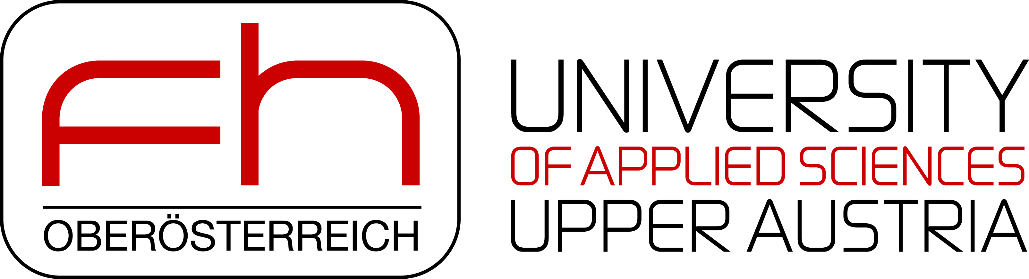
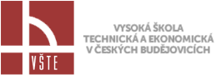
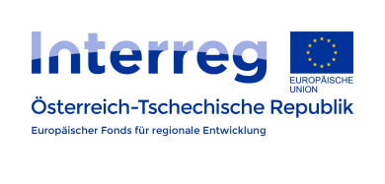

Protocol – Project Team Meeting

25.01.2018
Protocol # | 2/2018
Description | Project Team Meeting
Place | FH OÖ, Campus Hagenberg
Date | 25.01.2018
Time | 09:00 – 14:00
Participants | FH-OÖ: Martina Gaisch Victoria Rammer  VSTE: Jan Gregor, Libuse Turinska
Subjects of the meeting | - New finance manager on the Czech side  - Report of the first period  - The status report on the Czech side isn't approved yet  - We must ask whether we can still submit our amendment to the authority in Linz.  - Monography  - Collected monography  - “Call for paper” in CZ and English for more international output  - Austrian side can add some contributions e.g. CCBC Paper if we change it a bit we can use it also for the monography  - Write another paper with CLIL focus  - We also can ask other disciplines for some (CLIL) insights  - We can use the money from the journal publishing for the monography – we can as an international publisher if they publish the book  - We should try to get expert views, which we can add to our monography  - Monography should be open source  - Website Budget  - External expertise  - Offers for the website can only be obtained after approval of the change.  - Modules  - Modules that are not correct or do not make sense should be sent back.  - Mechanical engineering and civil engineering should be corrected by experts. Czech side try to find good experts  - New modules IT-Security and CRM System from the Austrian side  - Quality insurance is really important  - Austrian side will try to find students who can translate the technical modules during an internship (eg. mechanical engineering from Wels)  - Czech side can also translate modules to German and the Austrian side translate it to English – shift workload  - Austrian side will give feedback on the modules they already have  - Modules could be divided into two parts: “Basic” and “Experts”  - Finished presentations and modules will be sent to the Czech side. They transfer it to the e-learning system.  - Terminology list  - Definition and Context should be included  - E-learning: how can we make the terminology list more attractive to the user?  - E.g. Table with the same word in CZ, EN, DE with an explanation and context  - The design is really important  - Vocabulary training on the slides / gamification  - Need somebody for the technical part, e.g a student from the FH OÖ  - “large” terminology list as a booklet  - the most important words of the modules should be present in e-learning – added value = knowing this words within the field  - Workshop 21.06.  - Agenda of the workshop is okay for everyone  - Participants: 10-14 people from the Czech side  - Language: English, maybe one part in German – depends on the participants  - List of participants from the Czech side will be sent till the end of may  - 1 Day workshop – no need to stay overnight  - Project Report  - In Czech and German  - Czech partners write about the first Workshop  - Austrian partners write about the second Workshop  - Conference – together  - 4 Specialist/technical books  - We have to write a book for each programme (logistic, civil and mechanical engineering and informatics)  - Merge all the slides and information we have into a book  - Follow up project  - Integrated rescue system  - Training measures (foreign language, cross-border cooperation, cooperation of emergency medical services, fire brigade and police)  - Trainings for linguistic and cultural issues, conflict management, knowledge management (maintain of information in different processes), change management  - Help the services to cooperate between CZ and AT  - When would we have to submit?  - Pilot project:  - What we have to do? How should it look like?  - Who will take part?  - CCBC 2019 as a possible Date (13.05-17.05)  - Monday and Tuesday: Teaching Exchange  - Wednesday: International fair and excurses  - Thursday and Friday: Conference

