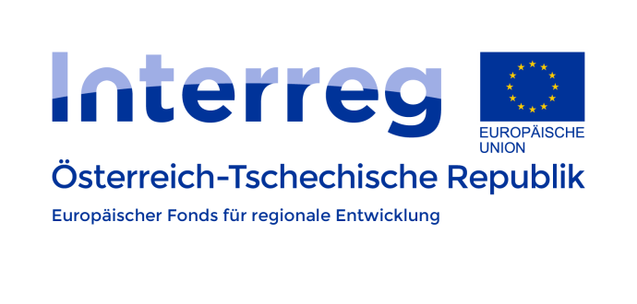
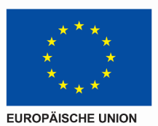
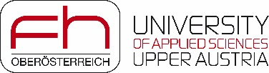

Project meeting
Date: 26.09.2018
Place: České Budějovice
Institution: Vysoká škola technická a ekonomická v Českých Budějovicích

Agenda
- Information on administration
- Project report
- Budget changes – current situation (language of monograph)
- 2nd monitoring report
- Web pages
- Completed information
- Uploading modules
- Information in 3 languages
- Modules
- Overview, translations
- Possible changes, modifications
- Further steps
- Terminology lists
- Keywords choice
- Number of keywords
- Final version
- Cooperation
- Monograph
- Concept
- Call for paper
- Contact
- Conference in Steyr 2019
- IBW
- Contribution – topic
- Cooperation
- Pilot project
- Plans for 2019

